Instructions for Setting up the Taste Test:

* At the table that has the supplies: cups/coffee filters, markers, gloves, and product:
  + Put gloves on first!
  + Label 48 cups/coffee filters Y and 48 cups/coffee filters Z.
    - Make sure all Y cups/coffee filters are grouped together on one side of the table and all Z cups/coffee filters are grouped together on the other side of the table.
  + Flip a coin to determine whether the name brand goes in the Y cups or the Z cups.
    - If coin lands on heads then:
      * The name brand will be placed into the cups/coffee filters labeled Y.
      * The bargain will be placed into the cups/coffee filters labeled Z.
    - If coin lands on tails then:
      * The name brand will be placed into the cups/coffee filters labeled Z.
      * The bargain will be placed into the cups/coffee filters labeled Y.
  + ***MAKE SURE YOU NOTE IN YOUR LAB BOOK WHETHER THE BARGAIN BRAND WAS LABELED AS Y OR Z.***
  + Create individual servings:
    - Pour enough of the drink cup for each student to get a taste of each drink (you have 4 cans of each soda or a gallon of apple juice total so just evenly distribute in the cups). Place one cookie into each coffee filter.
    - *Remember to put the correct product into cups/coffee filter labeled Y and the correct product into cups/coffee filters labeled Z (don’t mix them up). The assignment was determine by the coin flip.*
  + Clean up the area:
    - Remove all product packaging from the table – the only thing on the table should be the drinks/cookies in cups/coffee filters labeled Y and Z. (remember one section for Y and one section for Z).
    - Make sure you don’t have something visible that states whether the bargain brand was labeled Y or Z.
* Randomizing the order of Taste for Each Student:
  + At the table with the following supplies: Two buckets with beads (10 white beads and 10 non-white beads) and blank sheets of paper.
  + Draw one bead randomly from the bucket (only draw one bead and then shake up the bucket before drawing another bead).
  + Fill out the following sheets provided to you:
    - If you drew a white bead then fill out the sheet provided with the following order:

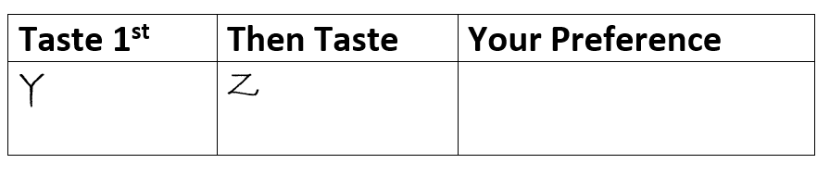

* + - If you drew a non-white bead then fill out the sheet provided with the following order:

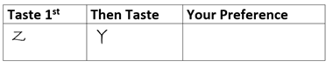

* + Keep going until you have 48 slips of paper filled out.
  + Place all slips of paper into a neat stack on a table (not the product table).
  + Students will pick up this paper before they go to the drink table and they will taste the drinks in the order on that sheet of paper.

*** There needs to be 48 slips for the drink product and 48 slips for the food product. Keep these in two different stacks on two different tables. ******

Directions to Collect the Data After the Set-up has Been Completed:

1. Select 6 members from the 12 that are working with the product (drink or cookie) to go to the other two lab rooms (LeConte 124 – downstairs near the Greene St side of the building, LeConte 205 – towards middle of hall, and LeConte 200A – at the end of the hall opposite of Greene St. on the left.) to taste the drink and cookie product they have setup in the same fashion as you just did.
2. The other 6 members will stay in their lab room, where you set up the product, to administer the taste test to students coming from the other two lab rooms.

******** ½ of you go taste in the other rooms and ½ of you stay in the room to help those coming to taste your product. Once your lab group members return you switch (those that stayed go and taste from the other rooms and those that went administer the taste test) ************************************************************

Giving instructions to students that come to taste your product:

1. Have 2 of your group members at a table that contains the sheets that tell the students which item to taste first and which item to taste second (they need to draw a paper and take it with them).
2. Have 2 of your group members at the table where the products are administered to make sure students are tasting in the order as it appears on the slip of paper they just picked up.
3. Have 2 of your group members at the remaining table to collect the sheets of papers. Students are to write down (have a pen or pencil available for those that didn’t bring one) which product they preferred (Y or Z). The student should not state their preference but write it down.

********* Each student that enters the room from one of the other labs should taste both the soda and the cookie in the room. DO NOT TASTE THE COOKIE IN THE ROOM WHERE YOU HAVE LAB *******

Compile the data and clean up the room:

* 1. Once all members from the other labs (it should be close to 48 students) have tasted the soda and food in the room then you can clean up the materials from the taste test. Everything but the slips of paper with the results should be thrown away. Any spills should be cleaned up and the tables should be wiped down with Lysol wipes.
  2. Give the lab instructor the slips of paper that contains the data. Do not mix up which slips go with the drink product and which slips go with the cookies. The lab instructor will read out the preferences from the slips of paper and all students should and fill out the table in your lab book on page 62 (table 8.4).

**** ONLY FILL OUT THE TABLE 8.4 FOR THE PRODUCT YOU WERE ASSIGNED TO SET UP ****

* 1. Fill in table 8.5 on page 62

***** Everyone in your lab group should have the same results as you ************************************

* 1. Answer the questions in your lab book

Before you leave:

1. Make sure you have all tables 8.4 and 8.5 filled out (this is the data you need to write your EWA).
2. Make sure you have answered all questions in the lab book. Make sure you have done all parts of the hypothesis test and confidence interval calculations as these must be in the appendix in the EWA and it must be done by hand.
3. Show your lab instructor your completed questions so you can get points for the lab in the gradebook.
4. Take all your work with you (including the questions you generally turn in) so you can write your paper.